WIFI CONTROLLED BY RC CAR USING ESP8266

Final year project report submitted to the department of Electronics and Communication Engineering in partial fulfilment of the requirements for the Diploma

By

K RAVITEJA (21155-EC-020)

Under the guidance of

Sri.. V RAVI SANKAR

Lecturer in ECE

Department of Electronics and Communication Engineering



Department of Electronics and communication Engineering
GOVERNMENT POLYTECHNIC, PILLARIPATTU
TIRUPATI CHENNAI BY PASS
PUTTUR - 517583

ACKNOWLEDGEMENT

We express our sincere gratitude to, Sri.V RAVI SANKAR Lecturer in ECE Government Polytechnic Pillaripattu, as the mentor for our project. It is our great fortune that we have got opportunity to carry out this project work under the supervision. We express our sincere thanks for the encouragement, support and the guidance. We would further like to thank all the faculty member for their cooperation and extended support in undergoing the project work. We also would thank the department of Electronics and Communication Engineering to provide the infrastructure and facility in carrying the projects like these.

K.RAVITEJA (21155-EC-020)

SHAIK MUZAMBEEL (21155-EC-043)

E.V.MANOJ KUMAR (21155-EC-016)

S.MANIKANTA CHARI (21155-EC-047)

M.CHITTI BABU (21155-EC-025)

P.UDA

CERTIFICATE

To whom it may concern

The undersigned certify that they have read and recommended to the Department of Electronics and Communication Engineering, Government Polytechnic, Pillaripattu, a final year project work entitled “WIFI CONTROLLED BY RC CAR USING ESP8266 ” submitted by K.RAVITEJA in partial fulfilment of the requirements for the Diploma in ECE during the academic year 2022-23 and that this project has not submitted previously for the award of any other degree, diploma and fellowship.

Sri. V Ravi Sankar

Lecturer in ECE
Department of ECE
Government Polytechnic,
Pillaripattu

G Rama krishna

Head of the Department,
Department of ECE
Government Polytechnic,
Pillaripattu

TABLE OF CONTENTS

CHAPTER NO. TITLE | PAGE No.
ABSTRACT | v
LIST OF FIGURES | viii
LIST OF SYMBOLS AND ABBREVIATIONS | x
1. INTRODUCTION | 1
1.1. GENERAL INTRODUCTION | 1
1.2. LITERATURE SURVEY | 2
1.3. SCOPE OF THE PROJECT | 4
1.4. ADVANTAGES | 4
2. PROJECT DESCRIPTION | 5
2.1. BLOCK DIAGRAM | 5
2.2. CONCEPT EXPLANATION | 7
2.3. CIRCUIT DIAGRAM | 7
2.4. HARDWARE REQUIREMENTES | 8
2.5. HARDWARE DESCRIPTION | 9
2.5.1. DC GEAR MOTOR | 9
2.5.1.1. GEAR MOTOR PERFORMANCE CURVE | 10
2.5.2. BD139 NPN TRANSISTOR | 11
2.5.2.1. BD139 NPN TRANSISTOR | 12
2.5.2.2. PIN CONFIGURATION | 12
2.5.2.3. FEATURES & SPECIFICATION | 13
2.5.2.4. CIRCUIT DIAGRAM | 14
2.5.2.5. APPLICATIONS | 15
2.5.3. L298 MOTOR DRIVER | 16
2.5.3.1. FEATURES | 17
2.5.3.2. APPLICATION | 17

2.5.3.3. L298N IC 17

      - CIRCUIT DIAGRAM 18

      - SPECIFICATION 18

      - PIN DIAGRAM 19

      - WORKING 19

      - MODULE PINOUT AND COMPONENTS 21

      - PINOUT OF L298N MOTOR DRIVER IC 23

    - ARDUINO NODEMCU 25

      - PIN DEFINITION 26

      - NODEMCU DEV KIT V1.0 PIN DESCRIPTIONS 27

2.5.5. 18650 BATTERY CELL 3.7v 38
- SIMULATION THEORY 39

  - ARDUINO DESCRIPTION 39

  - SIMULINK 39

- ARDUINO PROGRAMMING CODE AND PROTOTYPE MODE 40

4.1. CODE 40

  - ANDROID APP INTERFACE 51

  - PROTOTYPE MODEL 52

- CONCLUSION & FUTURE SCOPE 55

  - CONCLUSION 55

  - FUTURE SCOPE 55
REFERENCES 56

LIST OF FIGURES

FIGURE NO. FIGURE NAME PAGE NO.

  - Block diagram of Existing Syste Using Arduino
5

  - Block diagram of Proposed Syst Using node MCU
6

  - Hardware Circuit Diagram of Wi Control Robot Using Node MC
6

Circuit diagram for Proposed Mod

2.4.
Circuit Diagram of Wi-Fi Control R 8 Using Node MCU

  - DC Gear Motor 9

  - Performance Curve 10

  - BD139 NPN Transistor 11

  - BD139 Transistor Pin Configura 13

  - DC to DC Converter Circuit usi
 | BD139 Transistor
2.10. | L298 Motor Driver | 16
2.11. | L298N IC | 17
2.12. | CIRCUIT DIAGRAM | 18
2.13. | Pinouts of L298N Motor driver Mo | 21
2.14. | Pinouts of L298N IC | 23

14

  - NodeMCU Development Board/kit
(Version2)

25

  - NodeMCU Dev Kit v1.0(V2) Pino 26

  - NodeMCU GPIO 27

  - PWM DUTY CYCLE 30

  - NODEMCU PWM PINS 31

  - ADC PIN ON NODEMCU DEVK 32

2.21. | NodeMCU SPI Pins | 34
2.22. | NODEMCU UART PINS | 37
2.23. | 18650 Battery Cell | 38

LIST OF SYMBOLS AND ABBREVIATIONS

 | ω0 |  | - | Resonant Angular Frequency
 | Cr Cs Lr Ls  Ir |  | -  -  -  -  - | Resonant Capacitor Series Resonant Capacitor Resonant Inductor  Series Resonant Inductor  Resistance Current
 | R VC Vds Vin Vout Xc Xl  Z | - | -  -  -  -  -  -  - | Resistor Capacitor Voltage  Drain to Source Voltage  Input Voltage Output Voltage  Capacitive Reactance  Inductance Reactance Impedance
 | AC  API |  | -  - | Alternating Current  Application Program Interface
 | CCM |  | - | Continuous Conduction Mode
 | DCM |  | - | DisContinuous Conduction Mode
 | CISC |  | - | Complex Instruction Set Computer
 | CPU |  | - | Central Processing Unit
 | CTR  DC |  | -  - | Current Transfer Ratio  Direct Current

DCM | - | Discontinuous Current Mode
DIAC | - | Diode Alternating Current
DVM | - | Discontinuous Voltage Mode
ESR | - | Equivalent Series Resistance
ICSP | - | In Circuit Serial Programming
IGBT | - | Insulated Gate Bi-Polar Transistor
ILBC | - | Interleaved Boost Converter
MCLR | - | Master Clear
PFC | - | Power Factor Correction
PIC | - | Peripheral Interface Controller
SIM | - | Simulator
THD | - | Total Harmonic Distortion

CHAPTER 1 INTRODUCTION

GENERAL INTRODUCTION

In the present day, technology has so improved that an Unmanned Aerial Vehicle (UAV) also called as Drone can be controlled from a distance ranging from 2km to 20,000km. The Mars Rover, which was sent to Mars to explore various features of the planet is an autonomous robot which is programmed such that it performs the desired task as it is intended to do. There are many such systems which are controlled either by Radio Frequency transmission or by creating intelligence. Robots are called Non- autonomous robots. These robots have the programming logic to do the desired task but the decision power lies in the hand of controller (human) handling the robot. Here the interface can be made using two methods:
    - Wired –The connection between controller and robot is maintained using wired interface. This interfaces can be serial or parallel but the technology is transmission of signal, which is sent in the form of specific pattern to the robot to carry out the specific task, these patterns with the help of a microcontroller governing its motion.
    - Wireless –Here the connection between controller and robot is achieved by wireless interface such as: ➢Bluetooth
      - Wi-Fi
The underlying technology is transmission of signals wireless in air by transmitter which is captured by the receiver and sent to microcontroller mounted on the robot to carry out the task. At the present demand for robots in this developing world to carry out work effectively and accurately, the development of cost effective robots is necessary.

LITERATURE SURVEY

Yuxin Jing, Letian Zhang et-al implemented “An android Remote Control Car Unit for search missions “It is used in mean to be in a search for natural disasters. It has accomplished with the autonomous development to avoid obstacles if they are not visible by driver. Requirements for it’s implementation are Camera, Ultrasonic sensor, Bluetooth Servo Motor, Arduino UNO board, Wi-Fi router, Android studio. This application can make search operation more easier.

AyanMaity et-al implemented “Android application based Bluetooth controlled robotic car” Robot is controlled with the help of Bluetooth it is useful in moving vehicle forward, backward, left, right are Arduino UNO (ATMEGA 32), Bluetooth module (HC- 05), Smart phone, Motor driver (I293D).Main purpose of this robot is to detect hidden mines.

Rahul Kumar et-al implemented “Android Phone Controlled Bluetooth Robot” This paper dealswith design and control of vehicle capture live streams and videos at required location. Requirements for its implementation are Arduino Uno Board, DC Motors, Uart, L293D Motor Driver IC, Power adapter.

MehmetcanGule, Murat, Orthun et-al implemented “Android Based Wi-Fi Controlled robot using Raspberrpi” In this paper implementation is done for robot forward, backward, left, right and to display live stream of video using USB camera and raspberry pi board. Most inventive application is implemented to make people lives easier.

Jan Nadvornik, Pavel, Smutny et –al studied “Remote Control Robot Using Android Mobile Device”. The application allow robot to control interaction with display or voice when we use graphical user interface we can monitor current distance of obstacle from vehicle. Ultrasonic sensors are used to find distance of obstacle from vehicle.

Jayesh George et-al implemented “Android controlled smart car In this application they are generating commands for acceleration, brake, clutch and transmitting it to Microcontroller with the help of Bluetooth. Requirements for its implementation are microcontroller, Bluetooth HC05, DC geared motor, motor driver, Smart phone, Mikro C programming software, Pickit II Programmer, Tina Industrial Simulator, and Android Studio Android application helped in reducing difficulties in parking.

Benjir Ahmed et-al implemented “Android Apps Controlled ROBO Car by Microcontroller using Bluetooth” In this project they have developed a Robot named “ROBO car” controlled by Android apps from Smart phone through Bluetooth communication interfacing the microcontroller. According to the commands received from android phone, the direction, speed, sound and light of the car can be controlled. Requirements for its implementation are as follows Arduino UNO, Bluetooth module, Ultrasonic Distance Sensor, DC gear motor, Motor Driver, Boost Converter, Temperature Sensor, Android studio. The implemented Android apps controlled ROBO car worked successfully. It is easily controlled using Bluetooth communication between smart phone and microcontroller. It was observed that direction, speed, light, sound of the car will be controlled properly.

Chan Chung Hung et-al studied “Wi-Fi remote control car via mobile device” goal of this project was to build Wi-Fi remote control car via mobile device. Mobile device screen is the consist of buttons to plan distance, direction, mode of system but system has no accelerometer to show the readings for acceleration.

Raj Kumar Mistri et-al implemented “Wi-Fi controlled robot using node MCU” This is an embedded system. Aim of this project was controlling a robot from remote location of more than 1000 miles away. For its implementation are Power Supply, Node MCU, Motor and Motor Driver L293D, ESP2866 Wi-Fi module, wired interface. Controlling of the robot is tested successfully over the miles and application found efficient.

SCOPE OF THE PROJECT

In this work, Wi-Fi will be a key access technology for Internet of Things enablement due to cost coverage and bandwidth, challenges with mobile cellular which can be compromised through Wi-Fi. The motion of robot controlling via internet is one of the easy means as it requires the user to access the designated webpage to guide it. This system can be used in defence applications for detecting landmines in war field and for bomb detections by mounting a metal detector sensor on it. Further, the size of device can be miniaturized based upon specific applications. Further, the simulation of proposed work has been carried out using ARDUINO software and experimental values are validated with simulation parameters.

ADVANTAGES AND APPLICATIONS OF PROPOSED TECHNIQUE

- The proposed Wi-Fi controlled robot has
  - Can control it using smart mobile
  - high efficiency
  - Power consumption is very less
  - It’s easy to make further implementation with this robot

- The Microcontroller text input and gives output to the Wi-Fi module. Here by directional arrow has been between the Microcontroller and Wi-Fi module. Motor Driver is the by directional arrow has been used between the Microcontroller and Mobile Control Internet.

CHAPTER 2 PROJECT DESCRIPTION

BLOCK DIAGRAM OF WI-FI CONTROL ROBOT

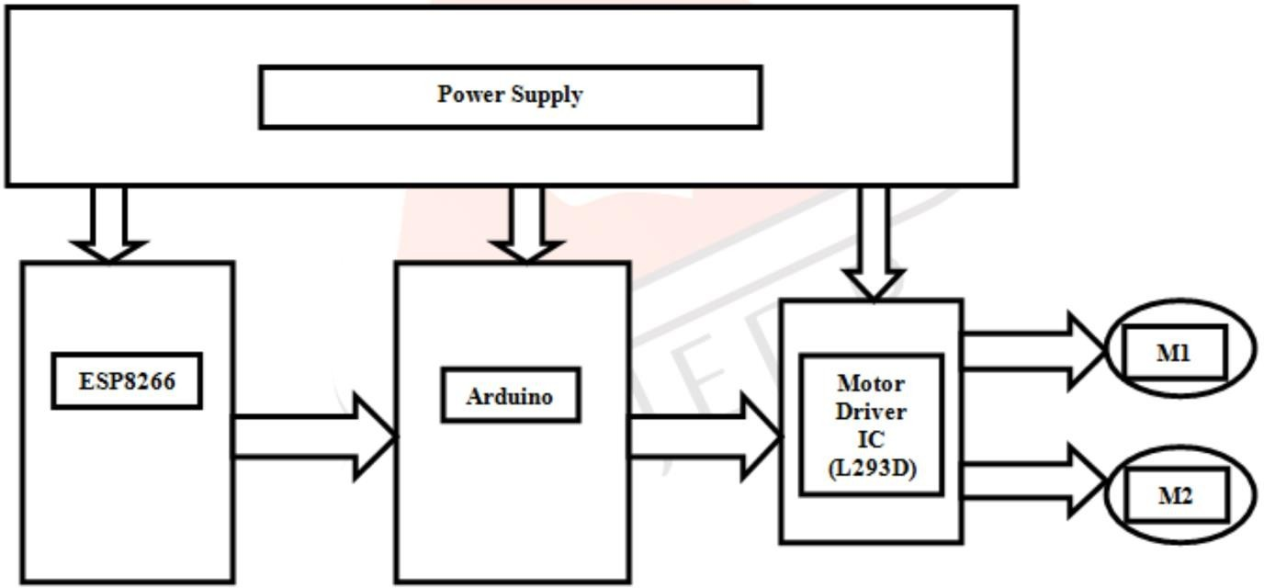

Fig 2.1 Block diagram of Existing System Using Arduino

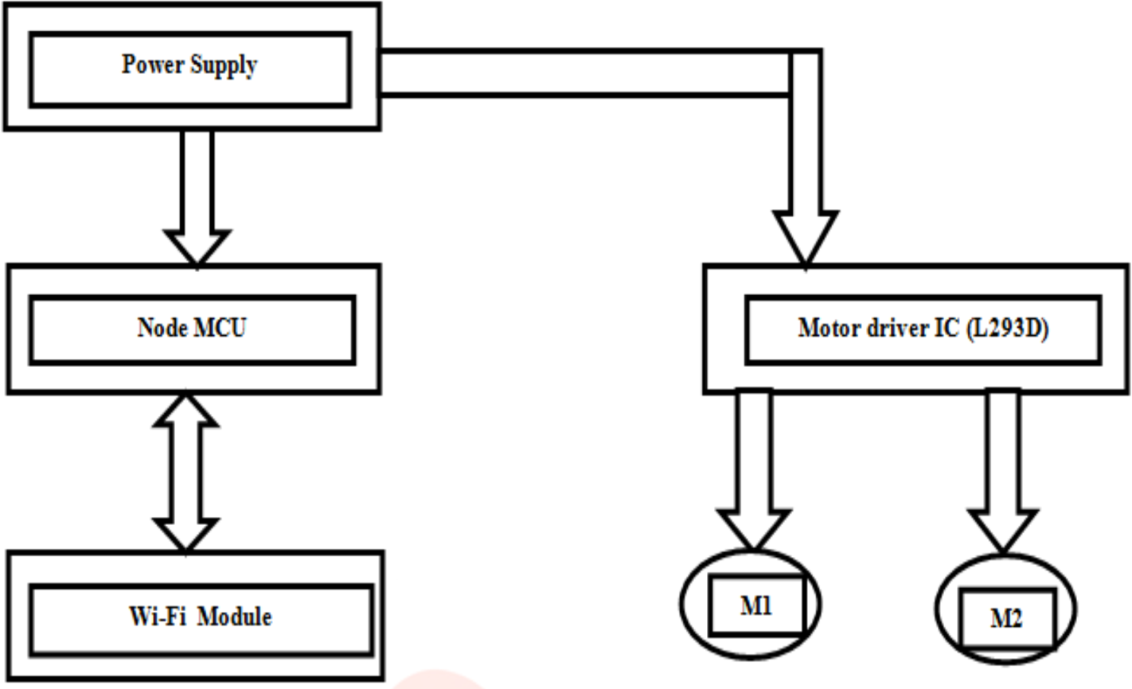

Fig 2.2 Block diagram of Proposed System Using node MCU

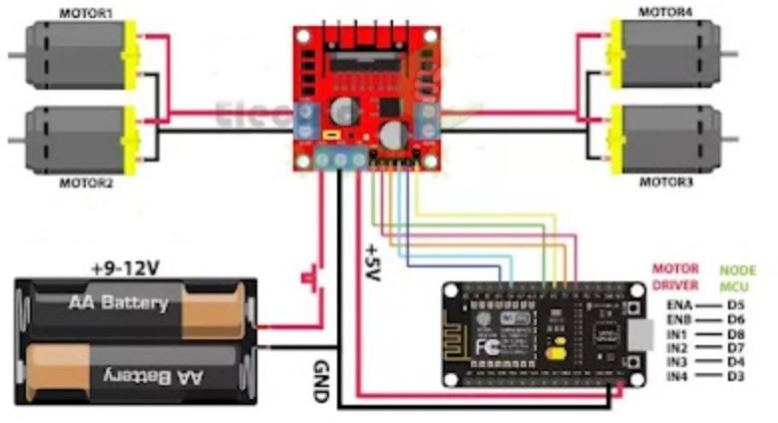

Fig 2.3 Hardware Circuit Diagram of Wi – Fi Control Robot Using Node
MCU

CONCEPT EXPLANATION:

EXISTING SYSTEM
Working of the Wi-Fi controlled robot is very easy, we just need to Drag or Slide the joystick in the direction, where we want to move the Robot. If we want to move the Robot in Forward direction then we need to Drag the Joystick ‘circle’ in Forward direction. Like we can move the Robot in Left, Right and Backward direction by Dragging the Joystick in respective direction. Now as soon as we release the Joystick, it will come back to centre and Robot. Blynk App sends values from Two Axis Joystick to Arduino through Wi-Fi medium. Arduino receive the values, compare them with predefined values and move the robot accordingly in that direction.

PROPOSED SYSTEM
A 12 Volt DC Power Supply has been apply to Microcontroller and Motor Driver. The Microcontroller text input and gives output to the Wi-Fi module. Here by directional arrow has been between the Microcontroller and Wi-Fi module. Motor Driver is the by directional arrow has been used between the Microcontroller and Mobile Control Internet.

CIRCUIT DIAGRAM

Circuit Diagram of Wi-Fi controlled robot is given below. We mainly need a NODEMCU and ESP8266 Wi-Fi module. ESP8266’s Vcc and GND pins are directly connected to 3.3V and GND of Node MCU and CH_PD is also connected with 3.3V. Transmitter and Receiver pins of ESP8266 are directly connected to pin 2 and 3 of NODEMCU. Software Serial Library is used to allow serial communication on pin 2 and 3 of Arduino. We have already covered the Interfacing of ESP8266 Wi-Fi module to NODEMCU in detail.

A L293D Motor Driver IC is used for driving DC motors Input pins of motor driver IC is directly connected to pin 8, 9, 10 and 11 of NODEMCU. And DC motors are connected at its output pins. Here we have use 9 Volt battery for driving the Circuit and DC motors.

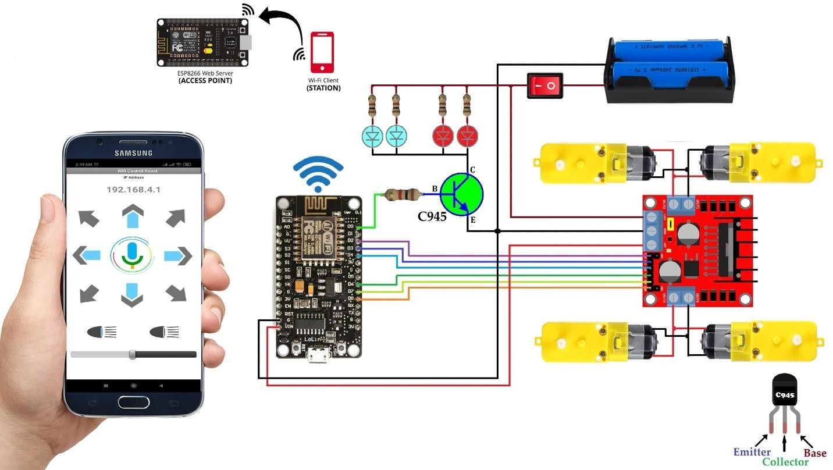

Fig.2.4 Circuit diagram for Proposed Modified Circuit Diagram of Wi-Fi Control Robot Using Node MCU

HARDWARE REQUIREMENTS

    - VPC Card board 5mm
    - Solder less Breadboard
    - DC Gear Motor x 4
    - Arduino Node-Mcu
    - L298 Motor Driver
    - BD139 NPN Transistor
    - 1k Resistor x 3
    - 100R Resistor x 2
    - White LED x 2, Red LED x 2
    - 4Pcs Smart Robot Car Tyers Wheels
    - Male to Male jumper Wires

    - Male to Female jumper Wires
    - On/Off Switch
    - 18650 Battery Holder – 2 Cell
    - 18650 Battery Cell 3.7V x 2

HARDWARE DESCRIPTION

    - DC GEAR MOTOR

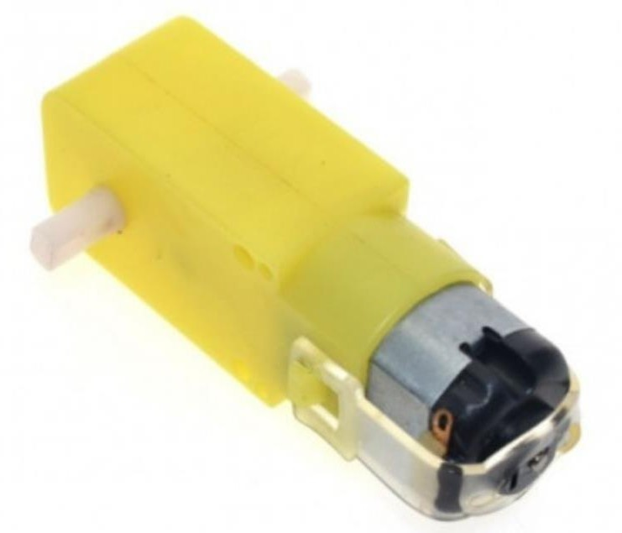A gear motor is an all-in-one combination of a motor and gearbox. The addition of a gear head to a motor reduces the speed while increasing the torque output. The most important parameters in regards to gear motors are speed (rpm), torque (lb-in) and efficiency (%). In order to select the most suitable gear motor for your application you must first compute the load, speed and torque requirements for your application. ISL Products offers a variety of Spur Gear Motors, Planetary Gear Motors and Worm Gear Motors to meet all application requirements. Most of our DC motors can be complemented with one of our unique gearheads, providing you with a highly efficient gear motor solution.
Fig.2.5 DC Gear Motor

GEAR MOTOR PERFORMANCE CURVE

A motors performance and gearbox performance are combined into one graph by displaying three specific parameters. These three parameters are speed, torque and efficiency. These performance curves are essential when selecting a gear motor for your application.

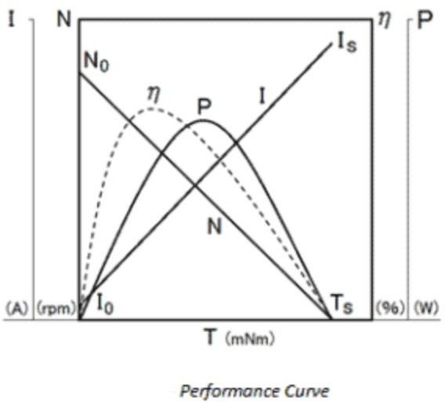
Fig.2.6 Performance Curve

Speed/Revolutions (N) – (unit: rpm) indicated as a straight line that shows the relationship between the gear motor’s torque and speed. This line will shift laterally depending on voltage increase or decrease.
        - Efficiency (η) – (unit: %) is calculated by the input and output values, represented by the dashed line. To maximize the gear motor’s potential it should be used near its peak efficiency.
        - Torque (T) – (unit: gf-cm) this is the load borne by the motor shaft, represented on the X-axis.

Current (I) – (unit: A) indicated by a straight line, from no load to full motor lock. This shows the relationship between amperage and torque.
        - Output (P) – (unit: W) is the amount of mechanical energy the gear motor puts out.

BD139 NPN TRANSISTOR

A Bipolar NPN transistor like BD139 is available in the SOT-32 plastic package. This kind of transistor is used in different electronic circuits because of less cost and high collector current. This transistor can drive up to 1.5A loads like motors, high power LEDs, relays, etc.
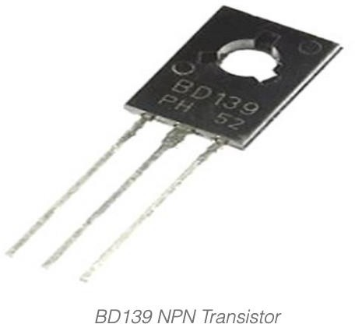
Fig.2.7 BD139 NPN Transistor

The VCE (collector-emitter) & VCB (collector-base) voltage is also extremely high thus it can simply use in an electronic circuit. The dissipation current of the collector terminal is 12.5W which is ideal to utilize in audio amplifier circuits. This transistor’s saturation voltage is simply 0.5V.

BD139 NPN TRANSISTOR WORKING

Once the current is applied at the base terminal of this transistor, then this transistor will work in forwarding bias. This current must be above as compared to its collector current. So at the base-emitter pin, we have to provide 5V.
When this transistor is working in forward biased condition, the maximum current drawn by emitter and collector terminals are 1.5A. If 1.5A of maximum current is supplying throughout this transistor then this transistor will be in Saturation Region.
Generally, we can provide a maximum of 80V across two terminals like emitter and collector. Once we detach the current supply at the base terminal of this transistor, then it will turn off, so this situation is known as the cut-off region.
This transistor is available in a plastic package but the medium power transistor is available in the metal package. This package will reduce its cost, it is not conductive & it will not be affected through other circuits. Because of this simple feature, this transistor is used mostly in amplifier applications.
This transistor is the best choice if you are looking for a transistor with medium power in a plastic package. BD139 transistor was manufactured by Phillips for specific audio applications at 160 MHZ, but it was cloned by different manufacturers like ST, Samsung, etc.

PIN CONFIGURATION

The pin configuration of the BD139 NPN Transistor is shown below. This transistor includes three pins which are discussed below.

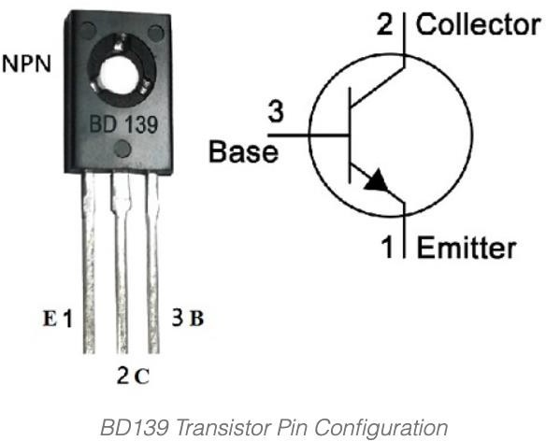
Fig.2.8 BD139 Transistor Pin Configuration

        - Pin1 (Emitter): An emitter terminal is connected to the GND terminal and this terminal drains out the current.
        - Pin2 (Collector): This is connected normally to load where the current supplies throughout this terminal.
        - Pin3 (Base): The base terminal controls the transistor biasing; it is used to switch ON/OFF the transistor.

FEATURES & SPECIFICATIONS

The main features and specifications of the BD139 transistor include the following.
        - The available package is To-225

        - It is mounted in a plastic case.

        - The Collector current (IC) of this transistor is 1.5A.

        - The collector Base voltage (VCB) of this transistor is 80V

        - Breakdown voltage from emitter to base (VBE) is 5V.

        - DC gain of this transistor (hfe) is 40 – 160

        - Breakdown voltage from emitter to base (VBE) is 5V

        - Its collector dissipation factor is 12.5w.

        - The range of junction temperature for operating & storage ranges from -55 to
+150°C

        - This transistor is also accessible within PB-Free packages.

Complementary BD139 transistor is BD140 whereas equivalent BD139 transistors are BD230, BD349, BD379, BD139G, BD179, BD169, BD230, BD237G, BD237, BD379, BD791, BD789, MJE242, MJE722/ MJE244 and 2SC5171S.

HOW TO USE BD139 TRANSISTOR/CIRCUIT DIAGRAM?

The circuit diagram of a 12Volts to 3Volts converter with a BD139 transistor is shown below. This is also known as DC to DC converter which is used by beginners of electronics in electronic projects.
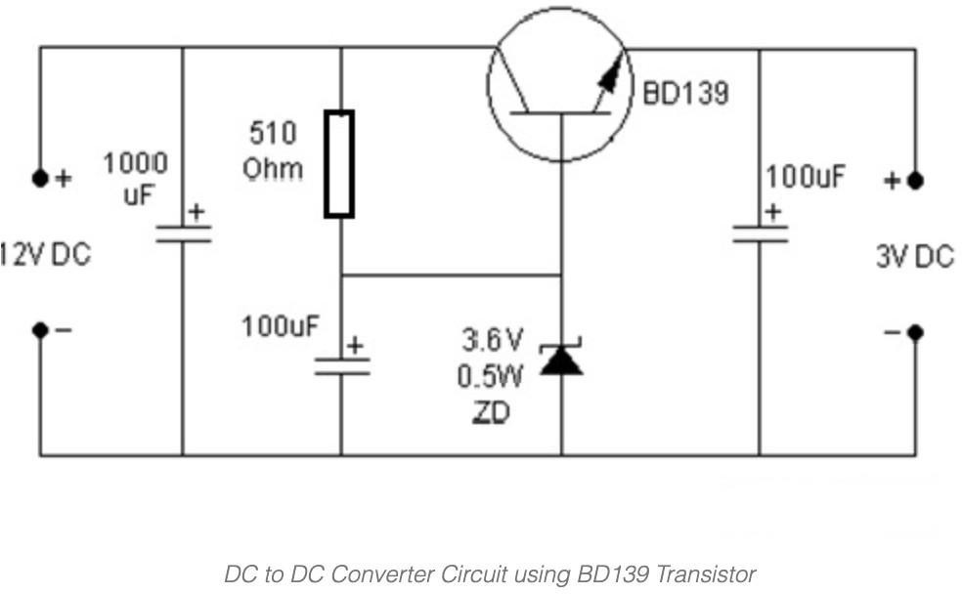The required components of this DC to DC converter circuit mainly include BD139 NPN transistor, 1000uF & 100uF capacitors, 12V DC, Zener Diode (3.6V/0.5W), Resistor (510 Ohms), Breadboard, connecting wires & Battery clips

Fig: 2.9 DC to DC Converter Circuit using BD139 Transistor

This type of converter provides a cheap, easy way to design a project. As a result, this simple 12V to 3V converter circuit is designed with a BD139 NPN Transistor & Zener diode.
The gain value of this transistor ranges from 40 to 160 which determines the amplification capacity for the transistor. The highest amount of current that could supply throughout the collector pin is 1.5A, thus we cannot fix loads that use above 1.5A with this transistor.
This transistor can be biased by supplying to the base terminal that must be restricted to 1/10th of the current at the collector terminal & the maximum voltage supply across the BE pin must be 5V.
By using this converter, we can obtain a stable & smooth 3V DC o/p. This circuit uses a Zener diode with 3.6V/0.5W like a voltage regulator. At the input 12V, DC is used where this input supplies throughout C1=1000uF smoothing capacitor to get rid of any leftover noise. After that, the DC signal goes throughout a Zener diode & generates a regulated 3Volts.
Here, the BD139 NPN transistor enhances the o/p current of this converter circuit to operate high current devices. We can also change 12V – 3V through a Zener diode & a resistor however it will not supply huge current. The 3V DC signal supplies throughout the ‘C3 = 100uF’ smoothing capacitor, before supplying to the output.
This DC to DC converter circuit is used in DVD players, portable chargers and to increase/decrease DC voltage in different applications. It is also used in power industries for the load matching process.

WHERE TO USE BD139 TRANSISTOR/APPLICATIONS

The applications of the BD139 transistor include the following.

        - BD139 transistor is mainly used in beginner electronics projects in the educational field like in Arduino projects, microcontroller projects, etc.

        - This transistor drives different loads up to 1500mA so we can drive & control different electronic equipment by using it.
        - This transistor can also be used in commercial electronics. When the load is driving above 200mA then the transistor will dissolve heat so a suitable heat sink is required.
        - This transistor is used in different applications like audio amplifiers, battery chargers, power supplies, motor drivers, under 1.5A of switching loads, Darlington pair, etc.
        - It is used like RF amplifier, in switching, load driver & amplification circuits

        - Used in audio & RF amplifiers.

L298 MOTOR DRIVER

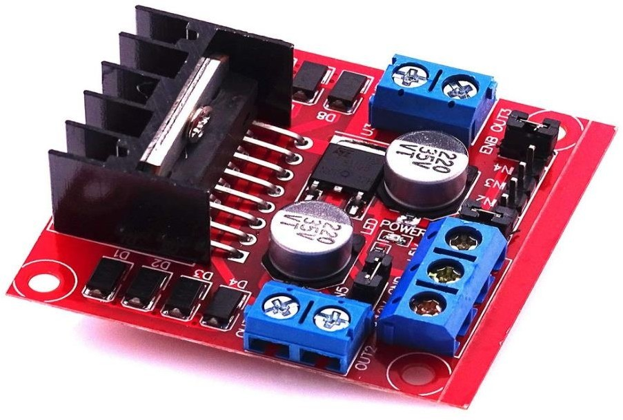The L298 Driver is a high voltage, high current dual ful bridge driver designed to accept standard TTL logic levels and drive inductive loads such relays, solenoids, DC and stepping motors. Two enable inputs are provided to enable or disable the device independently of the input signals. The emitters of the lower transistors of each bridge are connected together the corresponding external terminal can be used for the connection of an external sensing resistor.
Fig: 2.10 L298 Motor Driver

FEATURES

- Operating supply voltage up to 46 V & Total DC current up to 4 A
- Low saturation voltage
- Over temperature protection.
- Logical "0" input voltage upto1.5 V (HIGH NOISE IMMUNITY)
- Two motor direction indicator LEDs
- An onboard user-accessible 5V low-dropout regulator
- Schottky EMF-protection diodes
- Screw-terminals for power and motor connections.
- High quality PCB FR4 Grade with FPT Certified.

APPLICATION

        - MCU controlled vehicle.
        - Wheel robots.

L298N IC
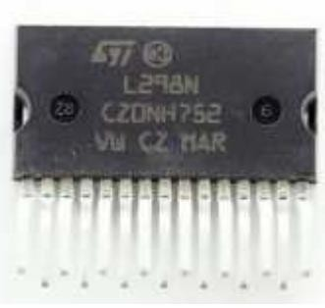

Fig: 2.11 L298N IC

CIRCUIT DIAGRAM

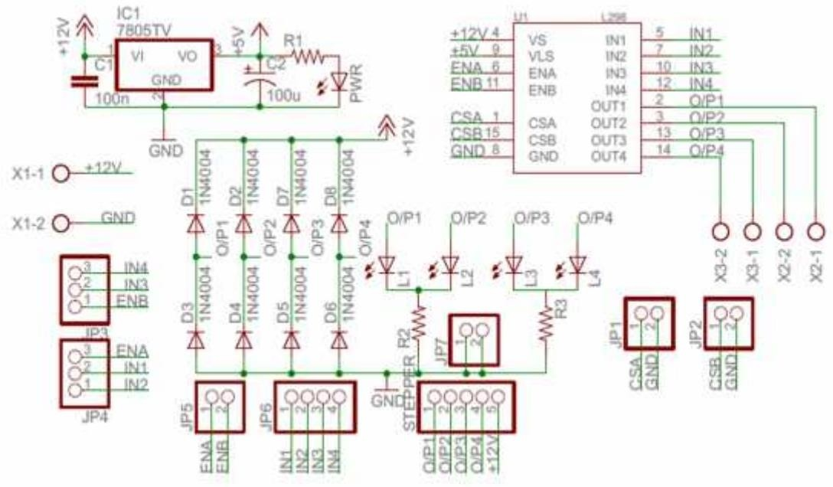

Fig: 2.12 CIRCUIT DIAGRAM

      - SPECIFICATION

PARAMETER | VALUE
Operating Voltage | Up to 46v
DC Current | 4A

PIN DIAGRAM

PIN | NAME | DETAILS
1 | GND | Ground
2 | +12V | Power Supply Input
3 | IN1 | Direction of motor 1
4 | IN2 | Direction of motor 1
5 | ENA | Controlling motor 1
6 | ENB | Controlling motor 2
7 | IN3 | Direction of motor 2
8 | IN4 | Direction of motor 2

      - WORKING

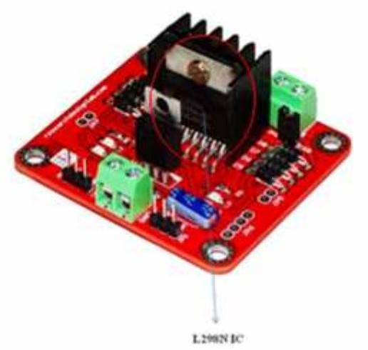

The L298 integrates two power output stages (A,B). The power output stage is a bridge configuration and its outputs can drive an inductive load in common or differential mode, depending on the state of the inputs. The current that flows through the load comes out from the bridge at the sense output : an external resistor (RSA, RSB.) allows to detect the intensity of this current.

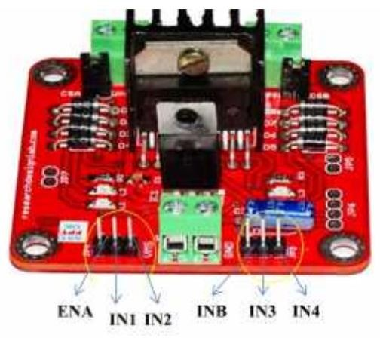

INPUT STAGE
Each bridge is driven by means of four gates the input of which are In1 ; In2 ; EnA and In3 ; In4; EnB. The In inputs set the bridge state when The En input is high ; a low state of the En input inhibits the bridge. All the inputs are TTL compatible. A non-inductive capacitor, usually of 100 nF, must be foreseen between both Vs and Vss, to ground, as near as possible to GND pin. When the large capacitor of the power supply is too far from the IC, a second smaller one must be foreseen near the L298. The sense resistor, not of a wire wound type, must be grounded near the negative pole of Vs that must be near the GND pin of the IC. Each input must be connected to the source of the driving signals by means of a very short path. Turn-On and Turn-Off : Before to Turn-On the Supply Voltage and before to Turn it OFF, the Enable in-put must be driven to the Low state.

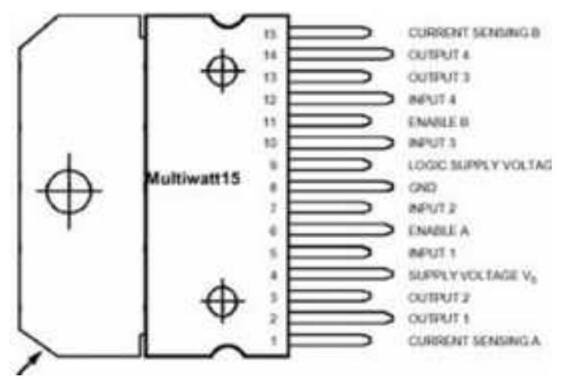
CURRENT SENSING

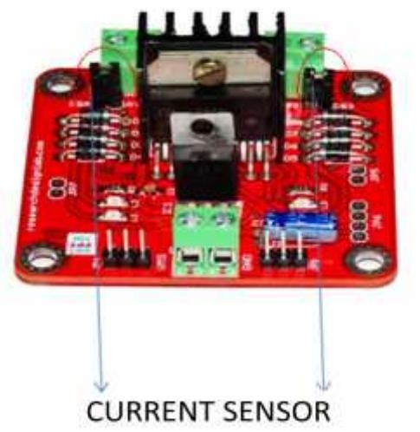
Pin 1,15 –current sensing A and B Between this pin and ground is connected the sense resistor to control the current of the load.

L298N MOTOR DRIVER MODULE PINOUT AND COMPONENTS

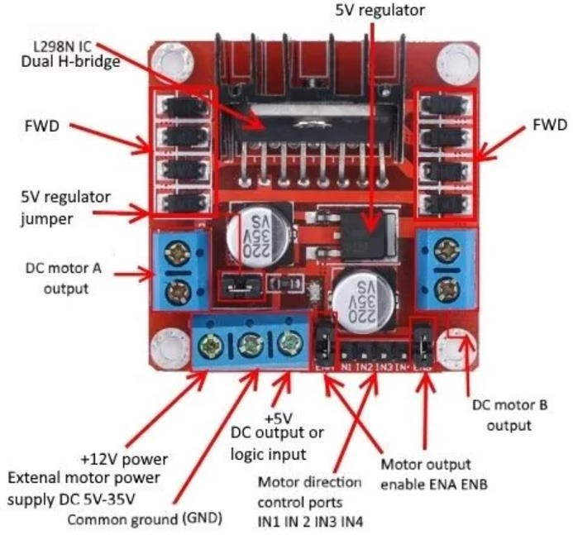The L298N Motor Driver module consists of an L298 IC Dual H-bridge, 5V 78M05 Voltage Regulator, resistors, capacitor, Power LED, 5V jumper.
Fig: 2.13 Pinouts of L298N Motor driver Module

2 DC motor output pins, 12-volt external motor power supply, motor direction control pins (IN1, IN2, IN3, IN4), motor output enable pins (ENA, ENB), and a heat sink.

VCC pin supplies power to the motor. Voltage anywhere between 5 to 35V can be applied. Remember, if the 5V-EN jumper is in place, you need to supply 2 extra volts than the motor’s actual voltage requirement, in order to run the motor at its maximum speed.

GND is the common ground pin.

5V pin supplies power to the switching logic circuitry inside the L298N IC. If the 5V-EN jumper is in place, this pin acts as output and can be used to power up the Arduino. If the 5V-EN jumper is removed, you need to connect it to the 5V pin on Arduino.

ENA pins are utilized to control the speed of Motor A. Supplying this pin with HIGH logic makes the Motor A rotate, supplying it with LOW logic causes the motor to stop. Removing the jumper and connecting this pin to the PWM input let us control the speed of the Motor A.

IN1 & IN2 pins are used to control the direction of Motor A. If IN1 is HIGH and IN2 is LOW, Motor A spins in a certain direction. To change the direction, make IN1 LOW and IN2 HIGH. If both the inputs are either HIGH or LOW, the Motor A stops.

IN3 & IN4 pins are used to control the direction of the Motor B. If IN3 is HIGH and IN4 is LOW, Motor B spins in a certain direction. To change the direction, make IN3 LOW and IN4 HIGH. If both the inputs are either HIGH or LOW, the Motor B stops.

ENB pin can be used to control the speed of Motor B. Supplying this pin with the HIGH signal makes the Motor B turn, supplying it LOW cause the motor to stop. Eliminating

the jumper and interfacing this pin to PWM information let us control the speed of Motor B.

OUT1 & OUT2 pins are connected to Motor A.
OUT3 & OUT4 pins are connected to Motor B.

      - PINOUT OF L298N MOTOR DRIVER IC

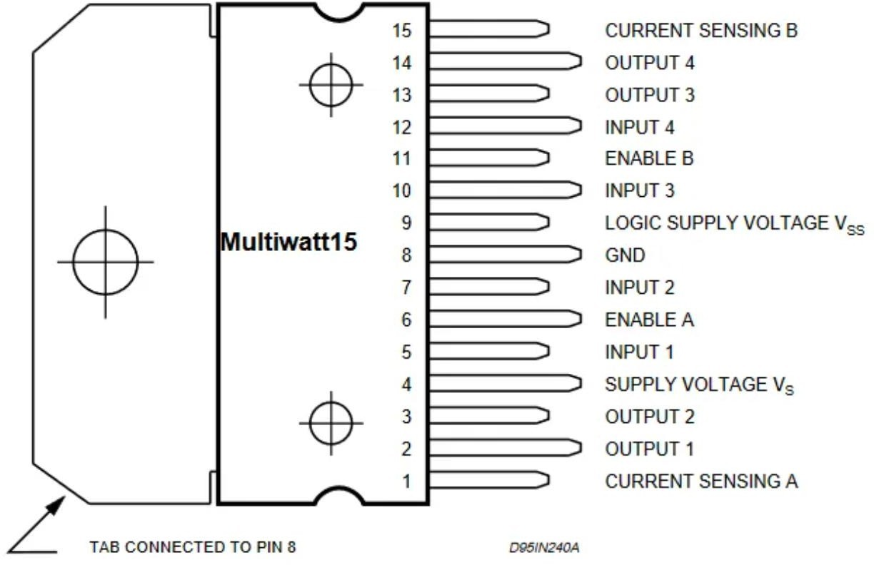

Fig: 2.14 Pinouts of L298N IC

L298N IC  pins | Name | Function
1,15 | Sense A, Sense B | Between this pin and the ground, a sense resistor is connected to control the current of the load.
2,3 | Out 1, Out 2 | Outputs of the Bridge A; the current that flows through the load connected between these two pins is monitored at pin 1.
4 | VS | Supply Voltage for the Power Output Stages. A non-inductive 100nF capacitor must be connected between this pin and ground.
5,7 | Input 1, Input 2 | TTL Compatible Inputs of the Bridge A.
6,11 | Enable A, Enable B | TTL Compatible Enable Input: the L state disables the bridge A(enable A) and/or the bridge B (enable B).
8 | GND | Ground
9 | VSS | Supply Voltage for the Logic Blocks. (A100nF capacitor must be connected between this pin and ground.)
10,12 | Input 3, Input 4 | TTL Compatible Inputs of the Bridge B.
13,14 | Out 3, Out 4 | Outputs of the Bridge B. The current that flows through the load connected between these two pins is monitored at the pin.

    - ARDUINO NODEMCU

NodeMCU is an open source IoT platform. It includes firmware which runs on the ESP8266 Wi-Fi SoC from Espressif Systems, and hardware which is based on the ESP-12 module. The term "NodeMCU" by default refers to the firmware rather than the development kits. The firmware uses the Lua scripting language.
Since NodeMCU is an open-source platform, its hardware design is open for edit/modify/build.NodeMCU Dev Kit/board consist of ESP8266 wifi enabled chip. The ESP8266 is a low-cost Wi-Fi chip developed by Espressif Systems with TCP/IP protocol. For more information about ESP8266, you can refer to the ESP8266 WiFi Module.
There is Version2 (V2) available for NodeMCU Dev Kit i.e. NodeMCU Development Board v1.0 (Version2), which usually comes in black colored PCB.

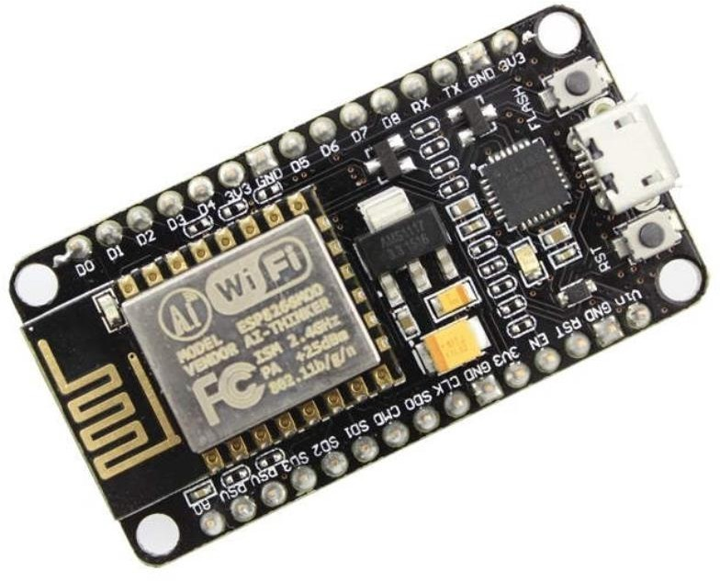
Fig: 2.15 NodeMCU Development Board/kit v1.0 (Version2)

For more information about NodeMCU Boards available in the market refer to NodeMCU Development Boards.
NodeMCU Dev Kit has Arduino like Analog (i.e. A0) and Digital (D0-D8) pins on its board.
It supports serial communication protocols i.e. UART, SPI, I2C, etc.
Using such serial protocols we can connect it with serial devices like I2C enabled LCD display, Magnetometer HMC5883, MPU-6050 Gyro meter + Accelerometer, RTC chips, GPS modules, touch screen displays, SD cards, etc.

      - 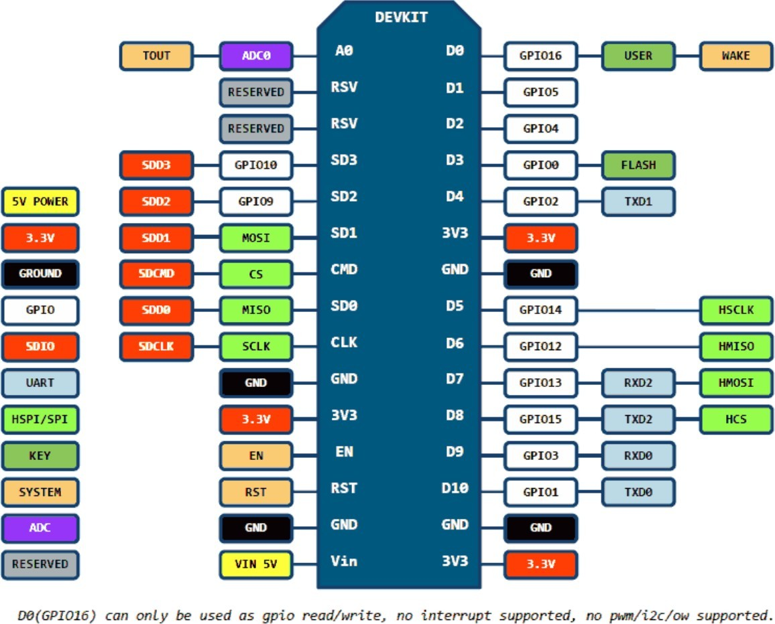PIN DEFINITION
Fig: 2.16 NodeMCU Dev Kit v1.0(V2) Pinouts

      - NODEMCU DEV KIT V1.0 PIN DESCRIPTIONS
27

GPIO (General Purpose Input Output) Pins:

NodeMCU has general-purpose input-output pins on its board as shown in the above pinout diagram. We can make it digital high/low and control things like LED or switch on it. Also, we can generate a PWM signal on these GPIO pins.

NodeMCU GPIO
General-purpose input/output (GPIO) is a pin on an IC (Integrated Circuit). It can be either an input pin or output pin, whose behavior can be controlled at the run time.
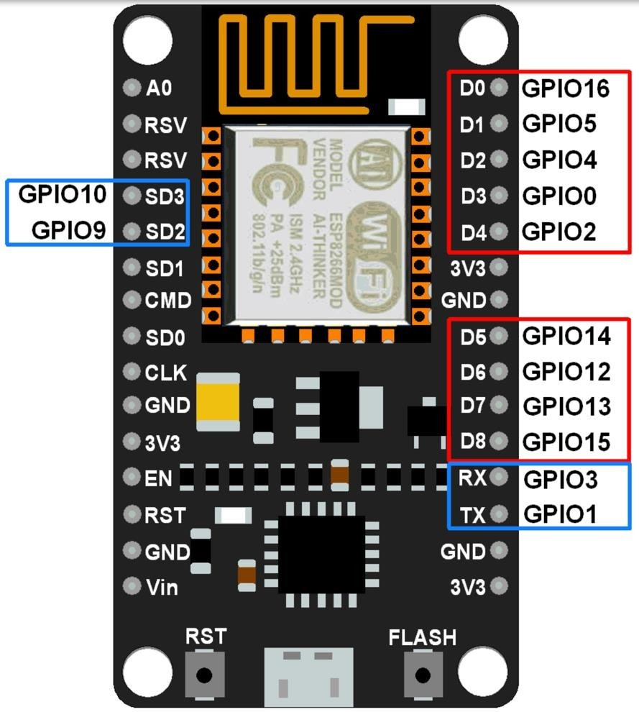
NodeMCU Development kit provides access to these GPIOs of ESP8266. The only thing to take care of is that NodeMCU Devkit pins are numbered differently than internal GPIO notations of ESP8266 as shown in the below figure and table. For example, the D0 pin on the NodeMCU Devkit is mapped to the internal GPIO pin 16 of ESP8266.
Fig: 2.17 NodeMCU GPIO

The below table gives NodeMCU Dev Kit IO pins and ESP8266 internal GPIO pins mapping
Pin Names on NodeMCU Development  Kit | ESP8266 Internal GPIO Pin  number
D0 | GPIO16
D1 | GPIO5
D2 | GPIO4
D3 | GPIO0
D4 | GPIO2
D5 | GPIO14
D6 | GPIO12
D7 | GPIO13
D8 | GPIO15
D9/RX | GPIO3
D10/TX | GPIO1
D11/SD2 | GPIO9
D12/SD3 | GPIO10

The GPIO’s shown in the blue box (1, 3, 9, 10) are mostly not used for GPIO purpose on Dev Kit.
ESP8266 is a System on Chip (SoC) design with components like the processor chip. The processor has around 16 GPIO lines, some of which are used internally to interface with other components of the SoC, like flash memory.
Since several lines are used internally within the ESP8266 SoC, we have about 11 GPIO pins remaining for GPIO purposes.
Now again 2 pins out of 11 are generally reserved for RX and TX in order to communicate with a host PC through which compiled object code is downloaded.
Hence finally, this leaves just 9 general-purpose I/O pins i.e. D0 to D8.
As shown in the above figure of NodeMCU Dev Kit. We can see RX, TX, SD2, SD3 pins are not mostly used as GPIOs since they are used for other internal

processes. But we can try with SD3 (D12) pin which mostly likes to respond for GPIO/PWM/interrupt like functions.
Note that the D0/GPIO16 pin can be only used as GPIO read/write, no special functions are supported on it.
Now let’s see about functions required to initialize pin to GPIO mode, setting pin direction and its state (High/Low).

NodeMCU PWM
Pulse Width Modulation (PWM) is a technique by which the width of a pulse is varied while keeping the frequency of the wave constant.
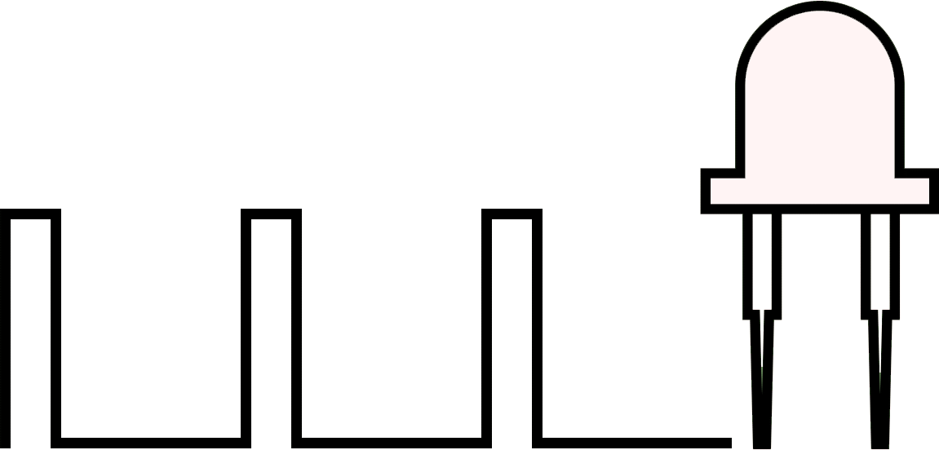

PWM Generation
A period of a pulse consists of an ON cycle (VCC) and an OFF cycle (GND). The fraction for which the signal is ON over a period is known as a duty cycle.

E.g. A pulse with a period of 10ms will remain ON (high) for 2ms.Therefore, the duty cycle will be
D = 2ms / 10ms = 20%

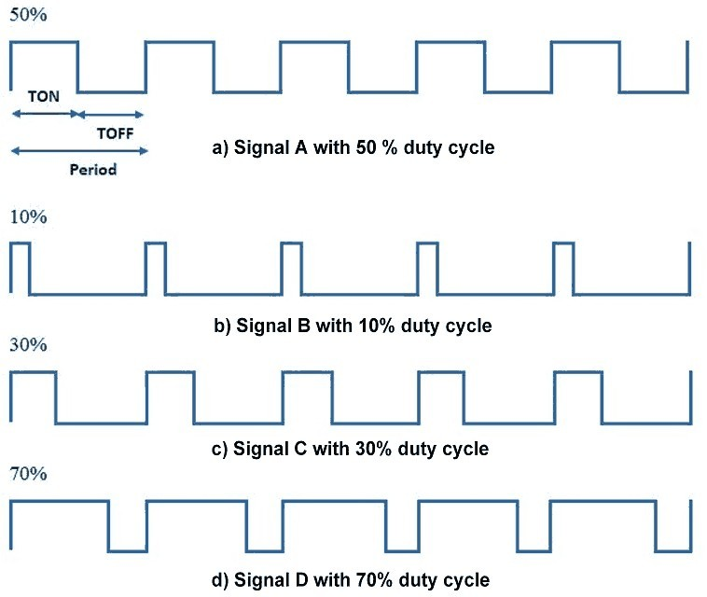
Through the PWM technique, we can control the power delivered to the load by using the ON-OFF signal. The PWM signals can be used to control the speed of DC motors and to change the intensity of the LED. Moreover, it can also be used to generate sine signals. Pulse Width Modulated signals with different duty cycles are shown below.

NodeMCU based ESP8266 has the functionality of PWM interfaces via software programming. It is achieved with the timer interruption method. The PWM frequency range for ESP8266 is adjustable up to 1KHz.
Fig: 2.18 PWM DUTY

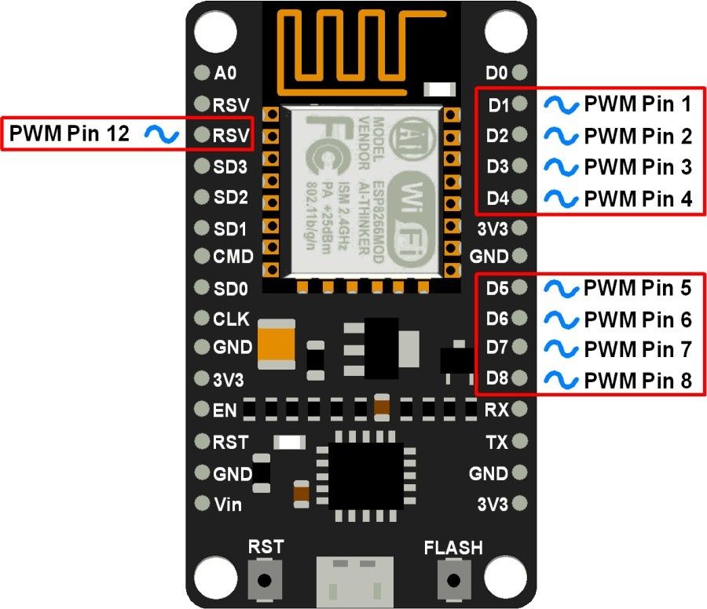
Fig: 2.19 NODEMCU PWM PINS

ADC (Analog to Digital Converter) channel (A0):

NodeMCU has one ADC channel/pin on its board.

NodeMCU ADC
Analog to Digital Converter(ADC) is used to convert the analog signals into digital form. ESP8266 has an inbuilt 10-bit ADC with only one ADC channel i.e. it has only one ADC input pin to read the analog voltage from external device/sensor.

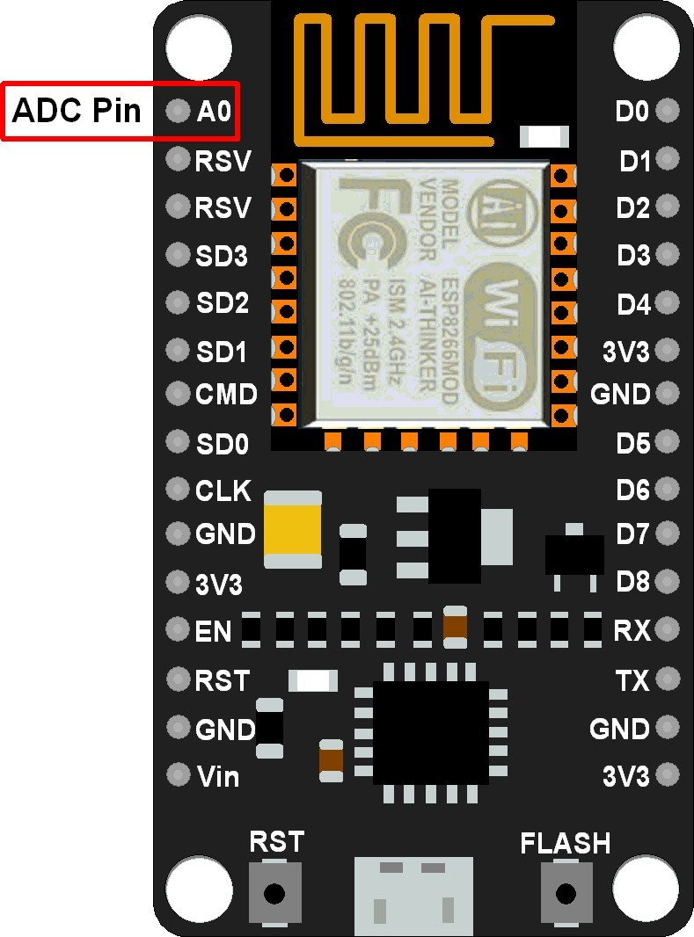
Fig: 2.20 ADC PIN ON NODEMCU DEVKIT

The ADC channel on ESP8266 is multiplexed with the battery voltage. Hence, we can set it to measure either onboard supply voltage or external analog voltage. The input voltage range for the ADC pin is 0–1.0V while reading external analog voltage.
The setting for ADC mode i.e. whether system voltage or external voltage is being measured is available in the 107th byte of “esp_init_data_default.bin” (0-127 byte) of the firmware.

SPI (Serial Peripheral Interface) Pins:

NodeMCU based ESP8266 has Hardware SPI (HSPI) with four pins available for SPI communication. It also has SPI pins for Quad-SPI communication. With this SPI interface, we can connect any SPI enabled device with NodeMCU and make communication possible with it.

NodeMCU SPI
The Serial Peripheral Interface (SPI) is a bus interface connection protocol originally started by Motorola Corp.

- SPI Interface uses four wires for communication. Hence it is also known as a four-wire serial communication protocol.
- SPI is a full-duplex master-slave communication protocol. This means that only a single master and a single slave can communicate on the interface bus at the same time.
- SPI enabled devices to work in two basic modes of SPI operation i.e. SPI Master Mode and SPI Slave Mode.
- The master Device is responsible for the initiation of communication. The master Device generates a Serial Clock for synchronous data transfer. Master Device can handle multiple slave devices on the bus by selecting them one by one.

NodeMCU based ESP8266 has Hardware SPI with four pins available for SPI communication. With this SPI interface, we can connect any SPI enabled device with NodeMCU and make communication possible with it.
ESP8266 has SPI pins (SD1, CMD, SD0, CLK) which are exclusively used for Quad-SPI communication with flash memory on ESP-12E, hence, they can’t be used for SPI applications. We can use the Hardware SPI interface for user-end applications.
The below figure shows Quad SPI interface pins that are internally used for flash. It consists of quad i/o (4-bit data bus) i.e. four (SDIO_DATA0 – SDIO_DATA3) bidirectional (i/p and o/p) data signals with synchronizing clock (SDIO_CLK) and chip select pin (SDIO_CMD). It is mostly used to get more bandwidth/throughput than dual i/o (2-bit data bus) interface.

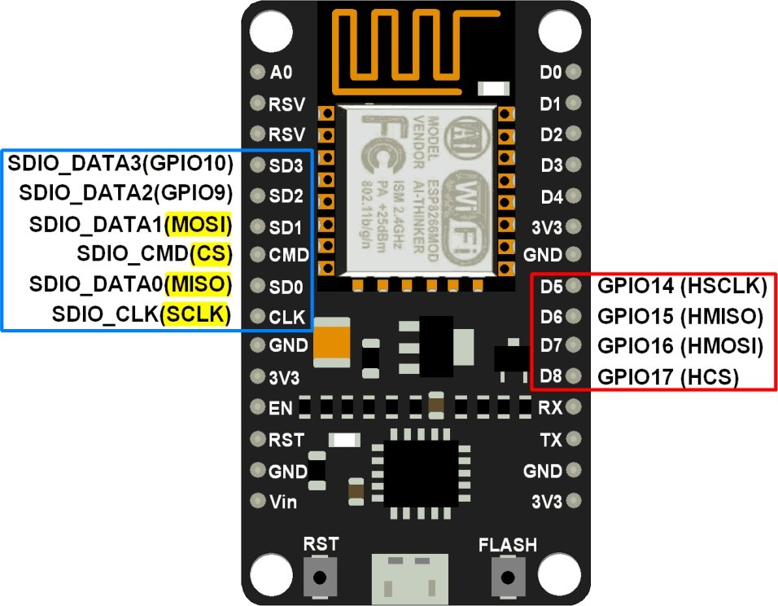
Fig: 2.21 NodeMCU SPI Pins

MISO (Master In Slave Out)

The Master receives data and the slave transmits data through this pin.

MOSI (Master Out Slave In)

The Master transmits data and the slave receives data through this pin.

SCLK (Serial Clock)

The Master generates this clock for the communication, which is used by
the slave.

Only the master can initiate a serial clock.

CS (Chip Select)

Master can select the slave device through this pin to start communication
with it.

I2C (Inter-Integrated Circuit) Pins:

NodeMCU has I2C functionality support on ESP8266 GPIO pins. Due to internal functionality on ESP-12E, we cannot use all its GPIOs for I2C functionality. So, do tests before using any GPIO for I2C applications.

NodeMCU I2C

I2C (Inter-Integrated Circuit) is a serial bus interface connection protocol. It is also called as TWI (two-wire interface) since it uses only two wires for communication. Those two wires are SDA (serial data) and SCL (serial clock).
I2C is an acknowledgment-based communication protocol i.e. transmitter waits for an acknowledgment from the receiver after transmitting data to know whether data is received by the receiver successfully.
I2Cworks in two modes namely,

- Master mode
- Slave mode

SDA (serial data) wire is used for data exchange between master and slave devices. SCL (serial clock) is used for the synchronous clock in between master and slave devices.
The master device initiates communication with the slave device. The master device requires a slave device address to initiate a conversation with the slave device. The slave device responds to the master device when it is addressed by the master device.
NodeMCU has I2C functionality support on its GPIO pins. Due to internal functionality on ESP-12E, we cannot use all its GPIOs for I2C functionality. So, do tests before using any GPIO for I2C applications.

UART (Universal Asynchronous Receiver Transmitter) Pins:

NodeMCU based ESP8266 has two UART interfaces, UART0 and UART1. Since UART0 (RXD0 & TXD0) is used to upload firmware/codes to the board, we can’t use them in applications while uploading firmware/codes.

NodeMCU UART

UART (Universal Asynchronous Receiver/Transmitter) is a serial communication protocol in which data is transferred serially bit by bit at a time. Asynchronous serial communication is widely used for byte-oriented transmission. In Asynchronous serial communication, a byte of data is transferred at a time.
UART serial communication protocol uses a defined frame structure for their data bytes. Frame structure in Asynchronous communication consists:

- START bit: It is a bit with which indicates that serial communication has started and it is always low.
- Data bits packet: Data bits can be packets of 5 to 9 bits. Normally we use an 8- bit data packet, which is always sent after the START bit.
- STOP bit: This usually is one or two bits in length. It is sent after the data bits packet to indicate the end of the frame. The stop bit is always logic high.
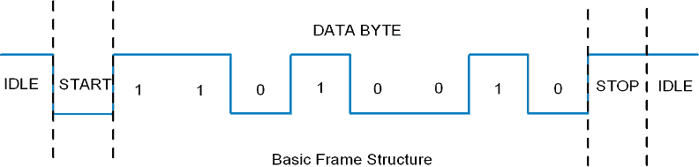

Usually, an asynchronous serial communication frame consists of a START bit (1 bit) followed by a data byte (8 bits) and then a STOP bit (1 bit), which forms a 10-bit frame as shown in the figure above. The frame can also consist of 2 STOP bits instead of a single bit, and there can also be a PARITY bit after the STOP bit.
NodeMCU based ESP8266 has two UART interfaces, UART0 and UART1. The ESP8266 data transfer speed via UART interfaces can reach 40 times of 115200 i.e. 4.5 Mbps. By default, the UART0 baud rate is 115200 for the oscillator of 40MHz. It can be changed to a user-defined value according to the need for the application.

Fig: 2.22 NODEMCU UART PINS

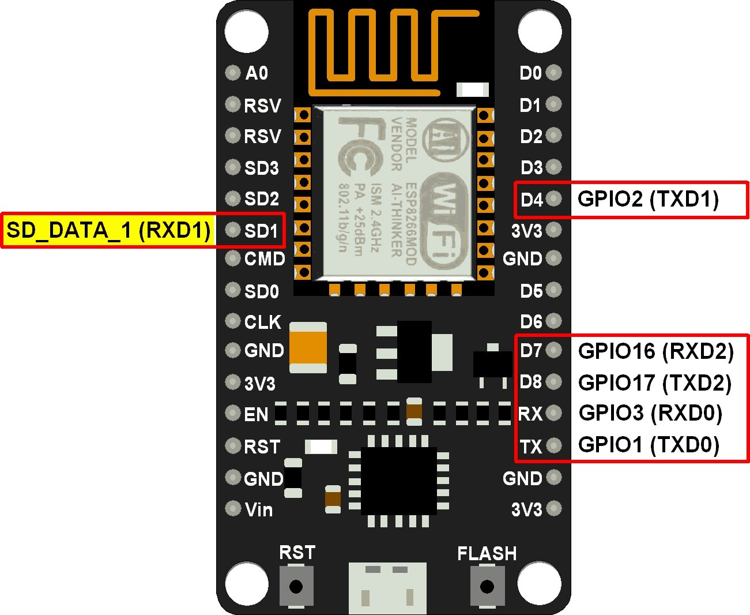
TXD (Data Transmit Pin)

This pin is used to transmit data serially.

RXD (Data Receive Pin)

This pin is used to receive data serially.
Note: SD_DATA_1/RXD1 pin is internally used for SPI quad communication with flash memory. Hence, we can only use the TXD1 pin from UART1.

    - 18650 Battery Cell 3.7V
An 18650 is a lithium ion rechargeable battery. Their proper name is “18650 cell”. The 18650 cell has voltage of 3.7v and has between 1800mAh and 3500mAh (mili-amp-hours).
18650s may have a voltage range between 2.5 volts and 4.2 volts, or a charging voltage of 4.2 volts, but the nominal voltage of a standard 18650 is 3.7 volts.
There are two types; protected and unprotected. We absolutely recommend protected cell 18650 batteries. Protected cells include a protection circuit that stops the cell from being overcharged.
Unprotected cells can be overcharged and burst or potentially cause a fire unless there are specific electronics to protect the battery. The popular LG HG2 and Samsung 25r are both UNPROTECTED batteries, only use them in a device designed to use unprotected 18650s
We also recommend you stick with high quality brand name 18650s. Knock offs may lie about high mAh.
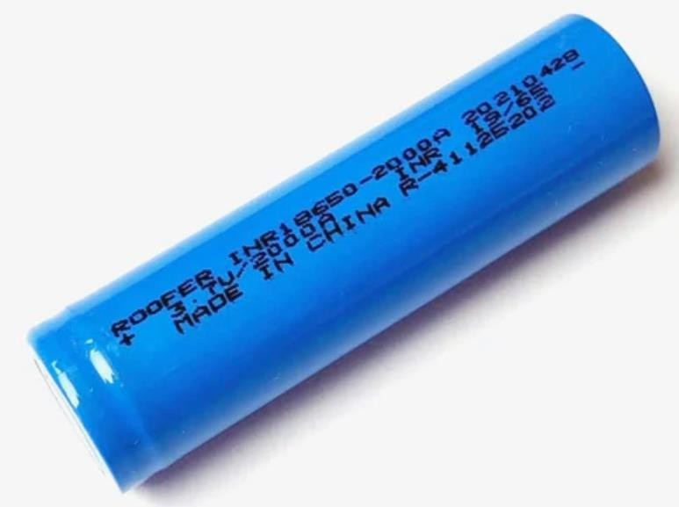The average 18650 battery charge time is about 4 hours. Charge time can vary with amperage and voltage of the charger and the battery type.
Fig: 2.23 18650 Battery Cell

CHAPTER- 3 SIMULATION THEORY

ARDUINO DESCRIPTION

Arduino is an open-source electronics platform based on easy-to-use hardware and software. Arduino boards are able to read inputs - light on a sensor, a finger on a button, or a Twitter message - and turn it into an output - activating a motor, turning on an LED, publishing something online.

SIMULINK

IDE stands for “Integrated Development Environment” :it is an official software introduced by Arduino.cc, that is mainly used for editing, compiling and uploading the code in the Arduino Device. Almost all Arduino modules are compatible with this software that is an open source and is readily available to install and start compiling the code on the go. In this article, we will introduce the Software, how we can install it, and make it ready for developing applications using Arduino modules. we introduce some simulators for this interesting microcontrollers development tools. It is easy to use and learn.

CHAPTER-4

ARDUINO PROGRAMMING CODE AND PROTOTYPE MODEL

ARDUINO PROGRAMMING CODE

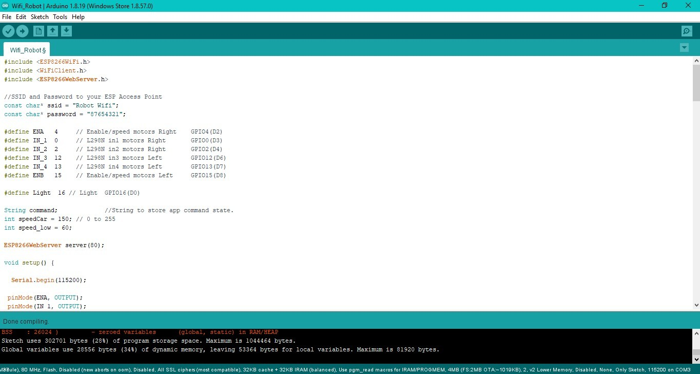

#include <ESP8266WiFi.h> #include <WiFiClient.h>

#include <ESP8266WebServer.h>

//SSID and Password to your ESP Access Point const char* ssid = "Robot Wifi";

const char* password = "87654321";

#define ENA | 4 | // Enable/speed motors Right GPIO4(D2)
#define IN_1 | 0 | // L298N in1 motors Right GPIO0(D3)
#define IN_2 | 2 | // L298N in2 motors Right GPIO2(D4)
#define IN_3 | 12 | // L298N in3 motors Left GPIO12(D6)
#define IN_4 | 13 | // L298N in4 motors Left GPIO13(D7)
#define ENB | 15 | // Enable/speed motors Left GPIO15(D8)

#define Light 16 // Light GPIO16(D0)

String command; //String to store app command state. int speedCar = 150; // 0 to 255

int speed_low = 60;

ESP8266WebServer server(80);

void setup() {

Serial.begin(115200);

pinMode(ENA, OUTPUT); pinMode(IN_1, OUTPUT); pinMode(IN_2, OUTPUT); pinMode(IN_3, OUTPUT); pinMode(IN_4, OUTPUT); pinMode(ENB, OUTPUT); pinMode(Light, OUTPUT);

// Connecting WiFi

WiFi.mode(WIFI_AP); //Only Access point

WiFi.softAP(ssid, password); //Start HOTspot removing password will disable security

IPAddress myIP = WiFi.softAPIP(); Serial.print("AP IP address: "); Serial.println(myIP);

// Starting WEB-server

server.on ( "/", HTTP_handleRoot ); server.onNotFound ( HTTP_handleRoot ); server.begin();

}

void loop() { server.handleClient();

command = server.arg("State");

if (command == "F") goForword(); else if (command == "B") goBack(); else if (command == "L") goLeft(); else if (command == "R") goRight();

else if (command == "I") goForwordRight(); else if (command == "G") goForwordLeft();

else if (command == "J") goBackRight(); else if (command == "H") goBackLeft();

else if (command == "W")digitalWrite(Light, HIGH); // light is on else if (command == "w")digitalWrite(Light, LOW); // light is off else if (command == "0") speedCar = 100;
else if (command == "1") speedCar = 120; else if (command == "2") speedCar = 140; else if (command == "3") speedCar = 160; else if (command == "4") speedCar = 180; else if (command == "5") speedCar = 200; else if (command == "6") speedCar = 215; else if (command == "7") speedCar = 230; else if (command == "8") speedCar = 240; else if (command == "9") speedCar = 255; else if (command == "S") stopRobot();

}

void HTTP_handleRoot(void) {

if( server.hasArg("State") ){ Serial.println(server.arg("State"));
}

server.send ( 200, "text/html", "" ); delay(1);
}

void goForword(){

digitalWrite(IN_1, HIGH); digitalWrite(IN_2, LOW); analogWrite(ENA, speedCar);

digitalWrite(IN_3, LOW); digitalWrite(IN_4, HIGH); analogWrite(ENB, speedCar);
}

void goBack(){

digitalWrite(IN_1, LOW); digitalWrite(IN_2, HIGH); analogWrite(ENA, speedCar);

digitalWrite(IN_3, HIGH); digitalWrite(IN_4, LOW); analogWrite(ENB, speedCar);
}

void goRight(){

digitalWrite(IN_1, LOW); digitalWrite(IN_2, HIGH); analogWrite(ENA, speedCar);

digitalWrite(IN_3, LOW); digitalWrite(IN_4, HIGH); analogWrite(ENB, speedCar);

}

void goLeft(){

digitalWrite(IN_1, HIGH); digitalWrite(IN_2, LOW); analogWrite(ENA, speedCar);

digitalWrite(IN_3, HIGH); digitalWrite(IN_4, LOW); analogWrite(ENB, speedCar);
}

void goForwordRight(){

digitalWrite(IN_1, HIGH); digitalWrite(IN_2, LOW); analogWrite(ENA, speedCar-speed_low);

digitalWrite(IN_3, LOW); digitalWrite(IN_4, HIGH); analogWrite(ENB, speedCar);
}

void goForwordLeft(){

digitalWrite(IN_1, HIGH); digitalWrite(IN_2, LOW); analogWrite(ENA, speedCar);

digitalWrite(IN_3, LOW); digitalWrite(IN_4, HIGH); analogWrite(ENB, speedCar-speed_low);
}

void goBackRight(){

digitalWrite(IN_1, LOW);

digitalWrite(IN_2, HIGH); analogWrite(ENA, speedCar-speed_low);

digitalWrite(IN_3, HIGH); digitalWrite(IN_4, LOW); analogWrite(ENB, speedCar);

}

void goBackLeft(){

digitalWrite(IN_1, LOW); digitalWrite(IN_2, HIGH); analogWrite(ENA, speedCar);

digitalWrite(IN_3, HIGH); digitalWrite(IN_4, LOW); analogWrite(ENB, speedCar-speed_low);

}

void stopRobot(){

digitalWrite(IN_1, LOW); digitalWrite(IN_2, LOW); analogWrite(ENA, speedCar);

digitalWrite(IN_3, LOW); digitalWrite(IN_4, LOW); analogWrite(ENB, speedCar);

}

  - ANDROID APP INTERFACE
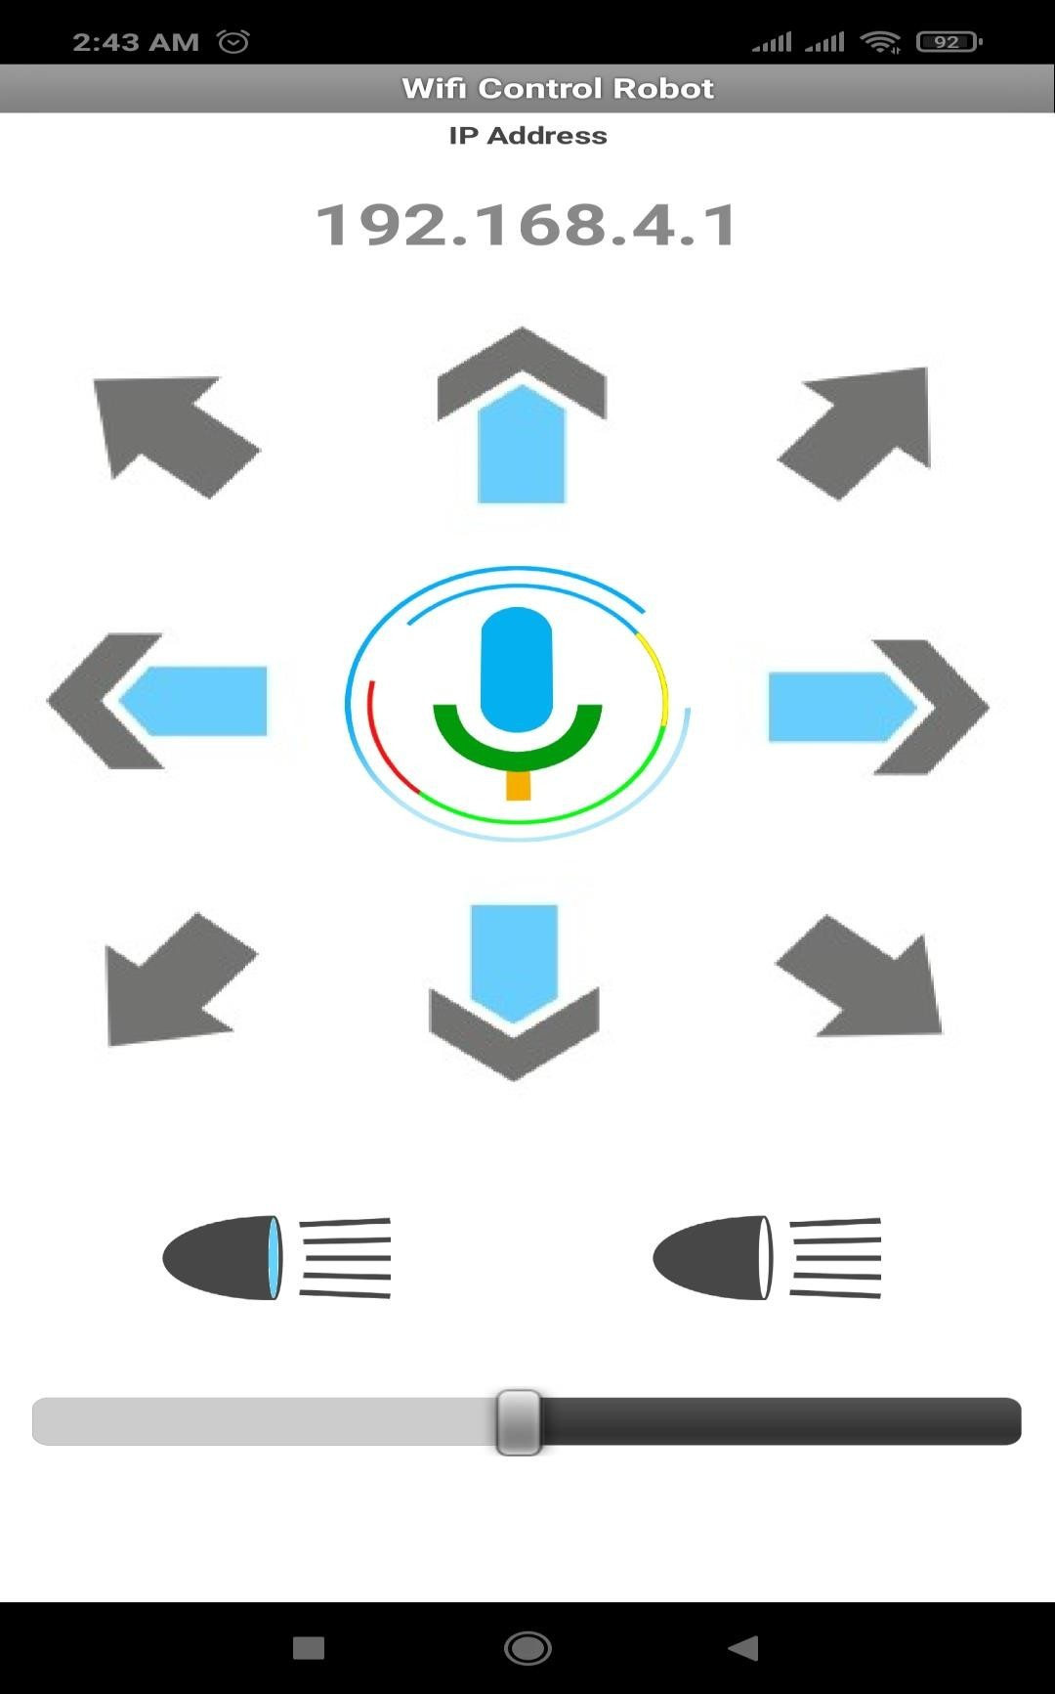

  - PROTOTYPE MODEL

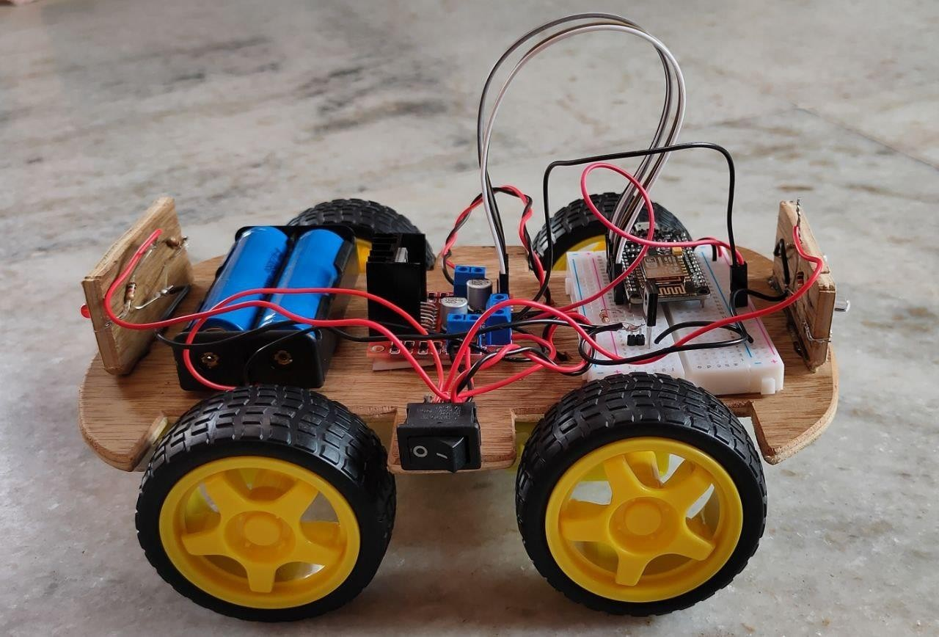

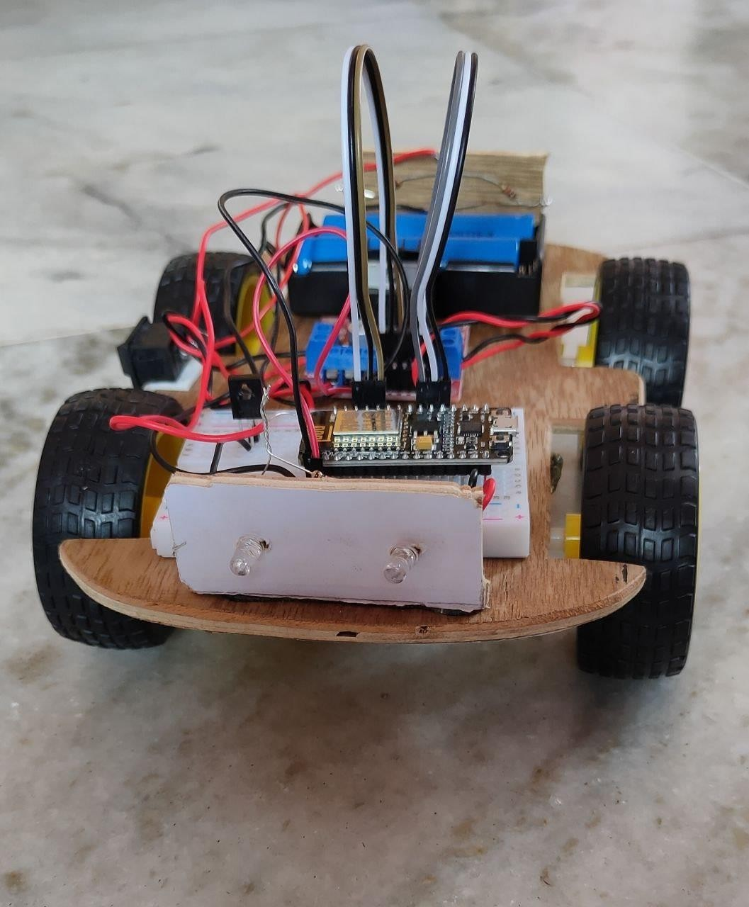

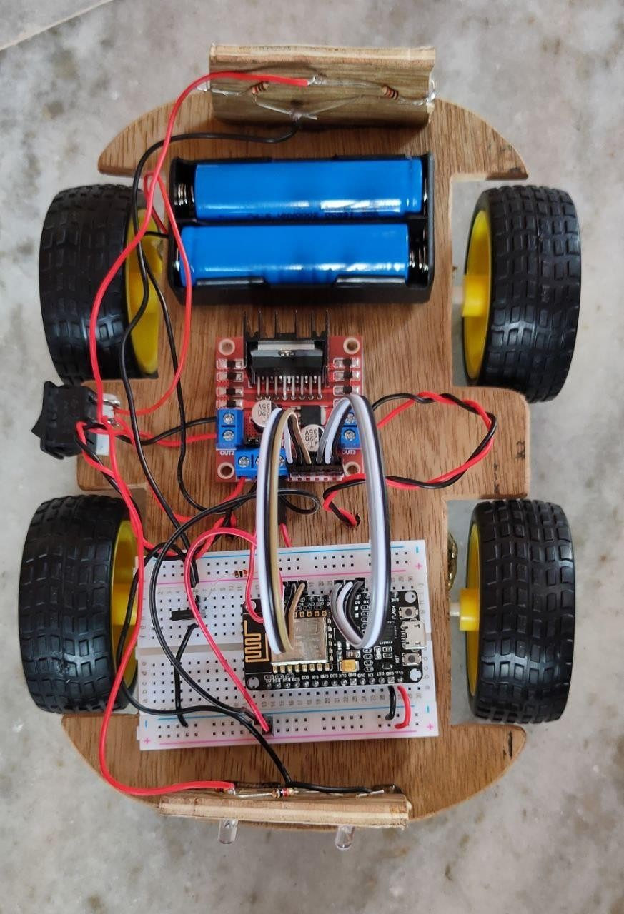

CHAPTER 5 CONCLUSION & FUTURE SCOPE

CONCLUSION:

` The hardware components are successfully assembled and interfacing the microcontroller with robot is achieved. Controlling the motion of robot via webpage as well as from android applet is successfully obtained.
Hence the two modules of controlling the robot is successfully tested and demonstrated. Though controlling using Bluetooth limits the range of distance for communication, a smart and easy means to guide a robot is achieved. Controlling the motion of robot via internet is one of the easiest means as it requires the user to access the designated webpage to guide it. This system can be used in defiance applications for detecting landmines in war field and for bomb detections by mounting a metal detector sensor on it. Further, the size of device can be miniaturized based upon specific applications.

FUTURE SCOPE:

For Internet of things Wi-Fi is the main technology used because of its cost coverage and bandwidth, in comparison with mobile cellular networks . As the technology is growing, imagination can be extended such that our future with only voice control system and Wi-Fi. Where the system is user friendly and less complex and can be readily used to perform assigned task immediately, also Several tedious and repetitive tasks. In the project the robot has been developed mainly for industrial usage. Further can be extended for other purposes such as commercial and research application.

REFERENCES

- Al- Sahib Nabeel.K& Azeez.Z Mohammed created “Internet Remote Control Interface for a Multi-Purpose Mobile Robot”.

- Andreasson.J, Gavert.M created “The Vehicle Dynamics Library Overview and Applications Modelon”.

- Cuno Pfister created “Getting started with Internet of Things”.

- Joy deep Biswas created “Wifi Localization and Navigation for Autonomous Indoor Mobile Robots”.

- Sudha Jamthe created”IoT Disruptions: The Internet of Things - Innovations & Jobs

- “Tom nguyen ,josh slonaker created “Semi Autonomous wireless control robot”.

- M.S.Sreejith, Steffy Joy created “Conceptual design of a wifi and gps based robotic library using an intelligent system.

- C.W.Warren , S.G.Buckley created “Mobile robotic over wifi network using arduino technology”.

- Harshit Gulati, Shriyannsh Vaishya created “Bluetooth and wifi control rescue robot”.

- Design of a Bluetooth Enabled Android Application for a Microcontroller Driven Robot By Vito M. Guardi,(May 2014).

- Jeonghye Han, Jaeyeon Lee, and Youngjo Cho, “Evolutionary role model and basic emotions of service robots originated from computers,” In the Proceedings of the IEEE International Workshop on Robot and Human Interactive Communication (ROMAN), pp. 30-35, 2005

- Moonzoo Kim, KyoChul Kang, and Hyoungki Lee, “Formal Verification of Robot Movements - a Case Study on Home Service Robot SHR100,” In the Proceedings of the IEEE International Conference on Robotics and Automation (ICRA), pp. 4739-4744, 2005

- Yeong Che Fai, Shamsudin H.M. Amin, NorsheilabtFisal, J. Abu Bakar. “Bluetooth Enabled Mobile Robot.” IEEE lCIT'02, Bangkok, THAILAND 2002.

- Andrey A. Loukianov, Hidenori Kimura, Masanori Sugisaka. “Implementing distributed control system for intelligent mobile robot” 8th International Symposium on Artificial Life and Robotics, Oita, Japan, January 24– 26 2003

- T. Butnaru, F. Gîrbacia, F. Tîrziu and D. Talab ,“Mobile Robot System Controlled Through Mobile Communications” Product Engineering, Springer, 2004

- Bischoff, R., and Graefe, V., “HERMES - a versatile personal robotic assistant,” Proceedings ofthe IEEE, vol. 92, pp. 1759-1779, 2004.

- Dong To Nguyen, Sang-Rok Oh, and Bum-Jae You, “A framework for Internet- based interaction of humans, robots, and responsive environments using agent technology,” IEEE Transactions on Industrial Electronics, vol. 52, Issue 6, pp. 1521-1529, 2005

- Gross, H.-M., Boehme, H.-J., and Wilhelm T., “Contribution to vision bas ed localization, tracking and navigation methods for an interactive mobile servicerobot,” In the Proceedings of the IEEE International Conference on Systems, Man, and Cybernetics, pp. 672– 677, 2001

- Lenser, S., and Veloso, M., “Sensor resetting localization for poorly modeled mobile robots,” In the Proceedings of the International Conference on Robotics and Automation (ICRA), pp. 1225–1232, 2000.

- Taipalus, T., and Kazuhiro K., “Development of service robot for fetching objects in home environment,” In the Proceedings of the IEEE International Symposium on International Research Journal of Engineering and Technology (IRJET) e-ISSN: 2395-0056 Volume: 08 Issue: 08 | Aug 2021 www.irjet.net p- ISSN: 2395-0072 © 2021, IRJET | Impact Factor value: 7.529 | ISO 9001:2008 Certified Journal | Page 1486 Computational Intelligence in Robotics and Automation (CIRA), pp. 451-456, 2005

- Yoshikazu K., Takayuki K., Yasuyuki S., Kiyoshi K., and Hiroshi I., “An Approach to Integrating an InteractiveGuide Robot with Ubiquitous Sensors,” In the Proceedings of the IEEE/RSJ International Conference on Intelligent Robots and Systems (IROS), pp. 2500- 2505,2004

- Ricardo Tesoriero, José A. Gallud, María D. Lozano, Víctor M. R. Penichet “Tracking Autonomous Entities using RFID Technology” IEEE Transactions on Consumer Electronics, Vol. 55, No. 2, MAY 2009

- Marcelo B. Perotoni , Beatriz E. Garibello, Silvio E. Barbin “ An IEEE802.11 Low Cost Planner Antenna for a Mobile Robot”, 2006

- Wi-Fi Robot For Video Monitoring & Surveillance System’ by Pavan.C, Dr. B. Siva kumar, International Journal of Scientific & Engineering Research Volume 3, Issue 8, August-2012 ISSN 2229-5518

- www.wifibot.com
- ‘Networking and Internet Applications’ by Sangay Yeshi
- https://www.rakeshmondal.info/L293D-Motor-Driver
- W.M.M. Seada, E. Kamal and M. A. Koutb, “Wireless Robot for Personal Mine Detection and Extraction Equipped with a Wide Range Metal Detector Sensor”, Volume 7, Issue 9, September-2016, International Journal of Scientific & Engineering Research.
- “Wireless control of surveillance robot”; kunalborker, Rohan gaikwad, Ajaysingh Rajput; IJARCSMS volume 2, issue 2, February 2014.
- “Robot controlled car using WI-FI module”; S.R. Madkar, vipul Mehta, NitinBhuvaniya, Maî tre parida; IJARCSSE volume 6, issue 5, may 2016.

